10211CS227 / Problem Solving and Testing
WEEK 1
Session 1 : Lambda Expressions
Task 1 : digitSum opt:sum of even or odd digits
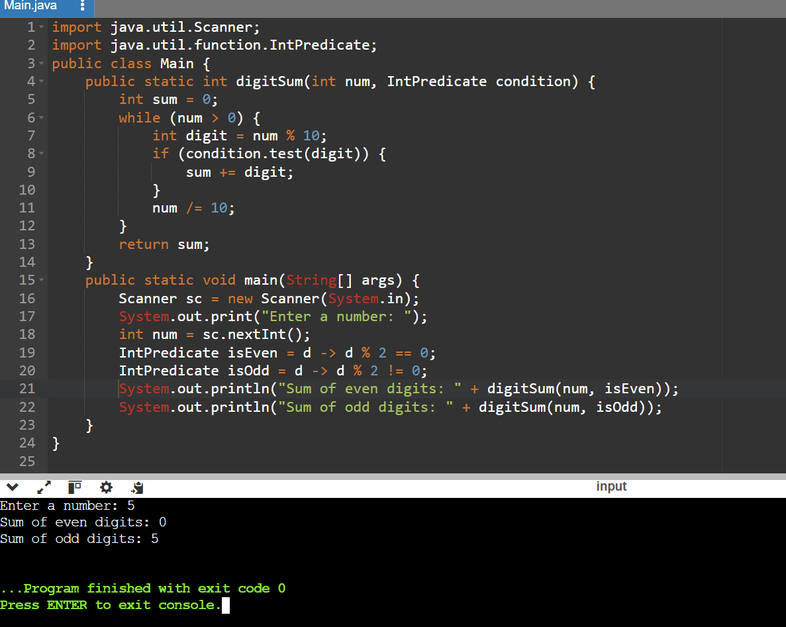
Task 2:Nth Fibonacci

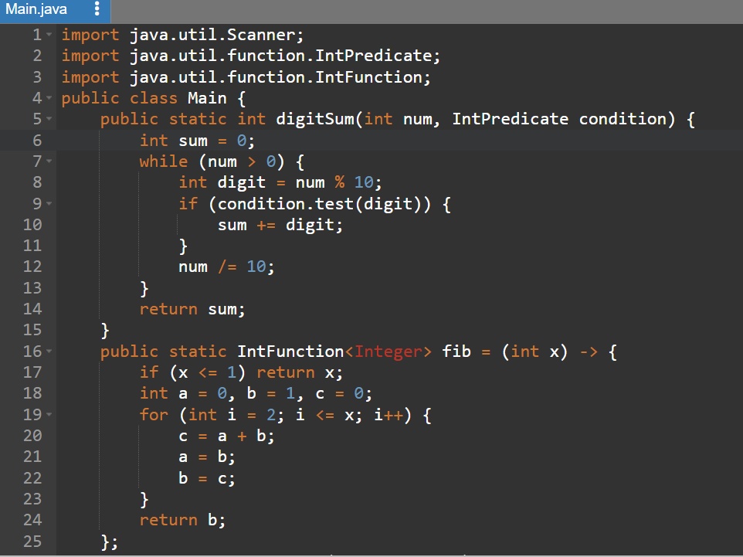
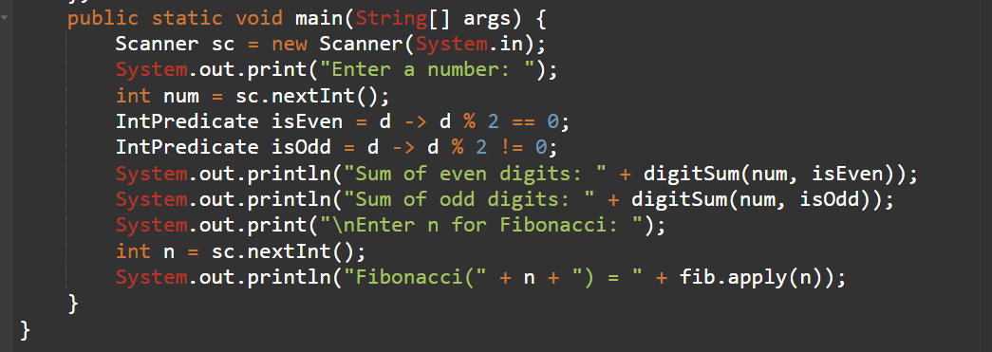
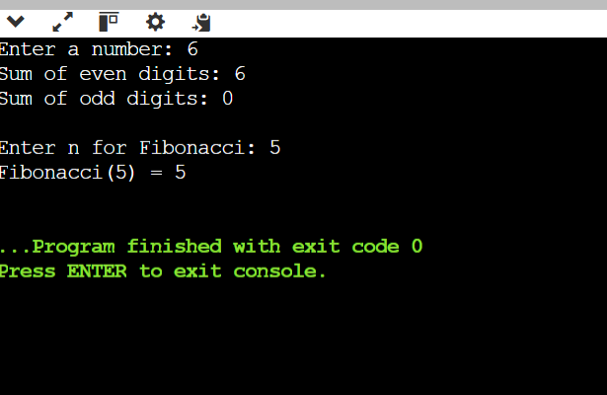
Session 2
Functional Interfaces & Method References
Task 3: Is Palindrome Number?
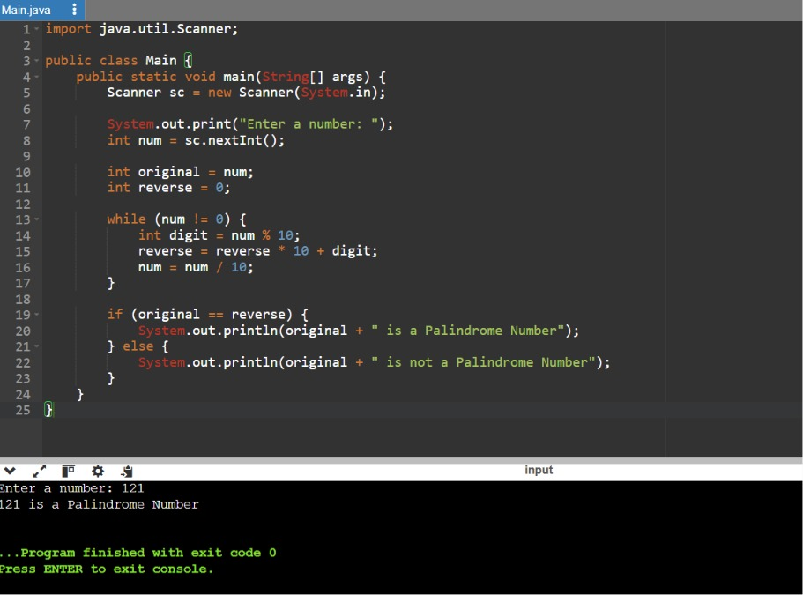
Task 4 : Sum Of last digit of two given numbers
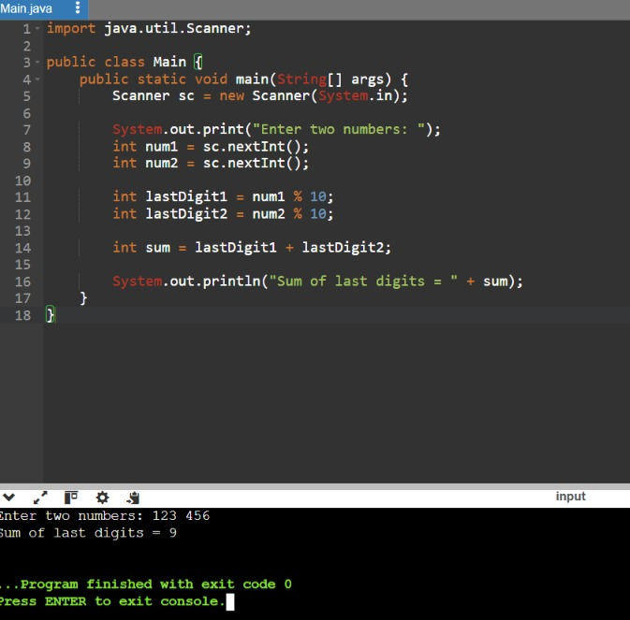
Session 3
Task 5:Number of primes in a specified range
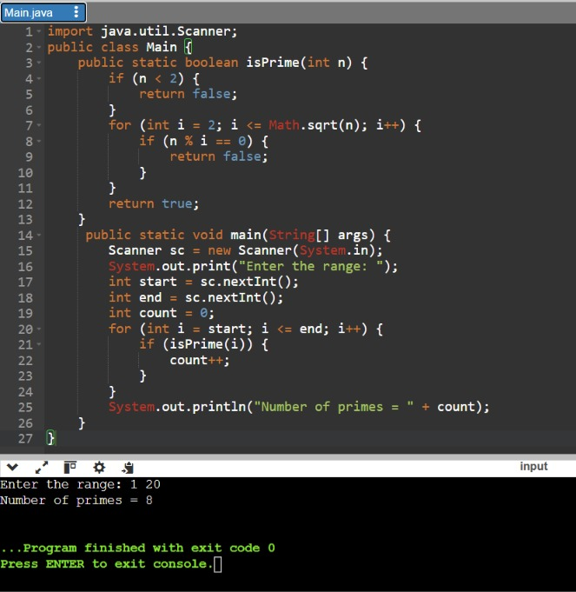
Task 6 : Sum of power of digit
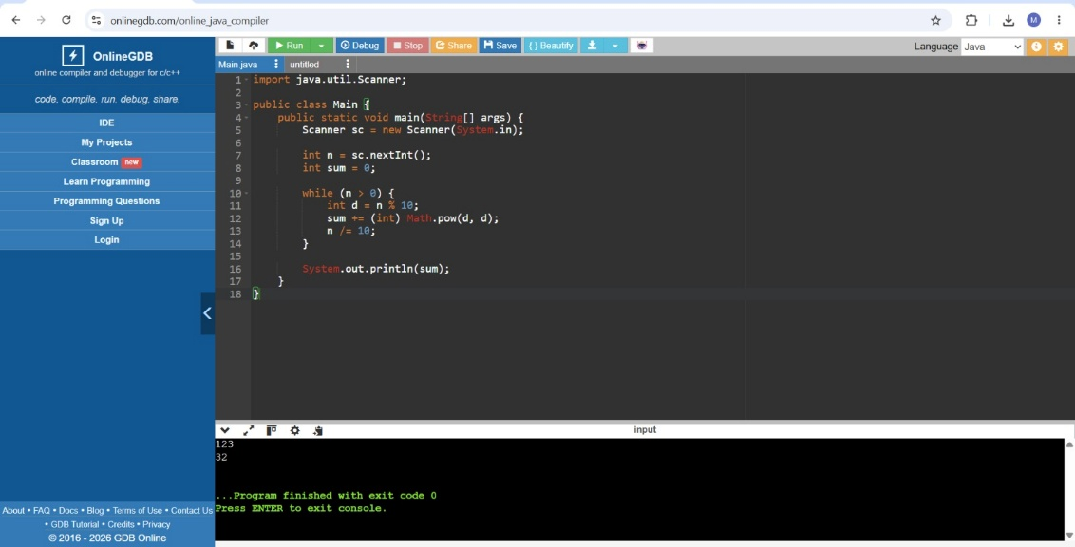
Session 3:
Task 7: Unique digit count
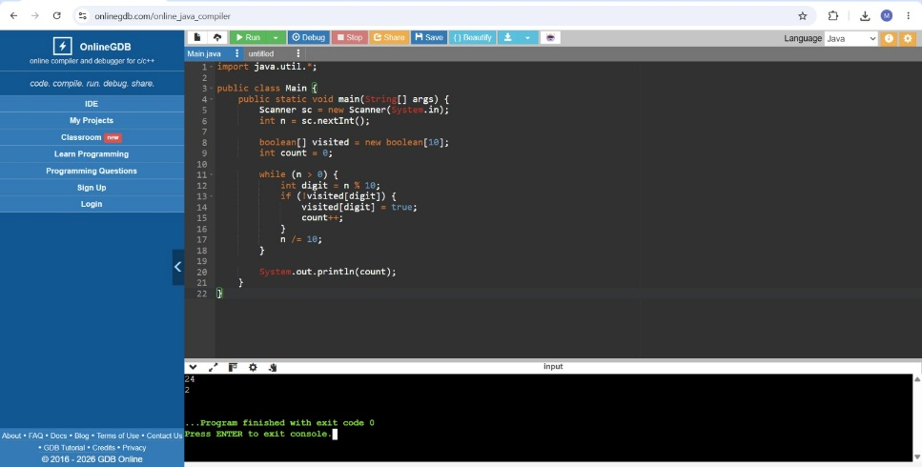
Task 8 : Most frequently occurring digit
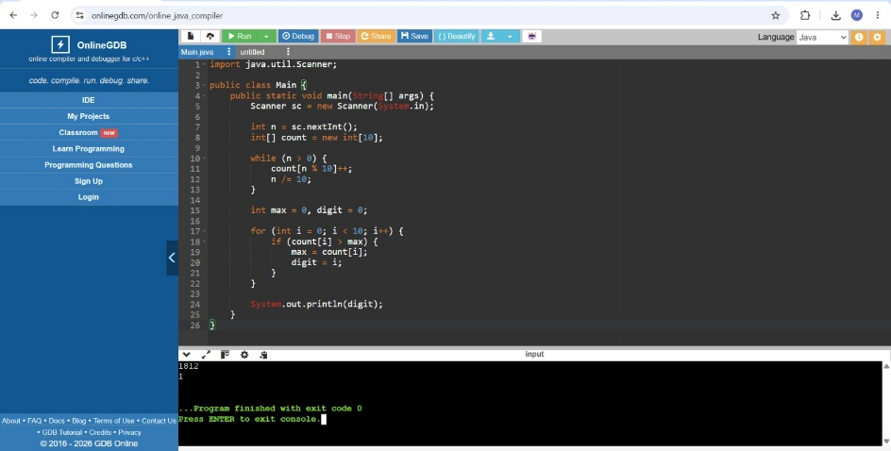
Session 5
Task 9 : Calculate sum of non prime index values
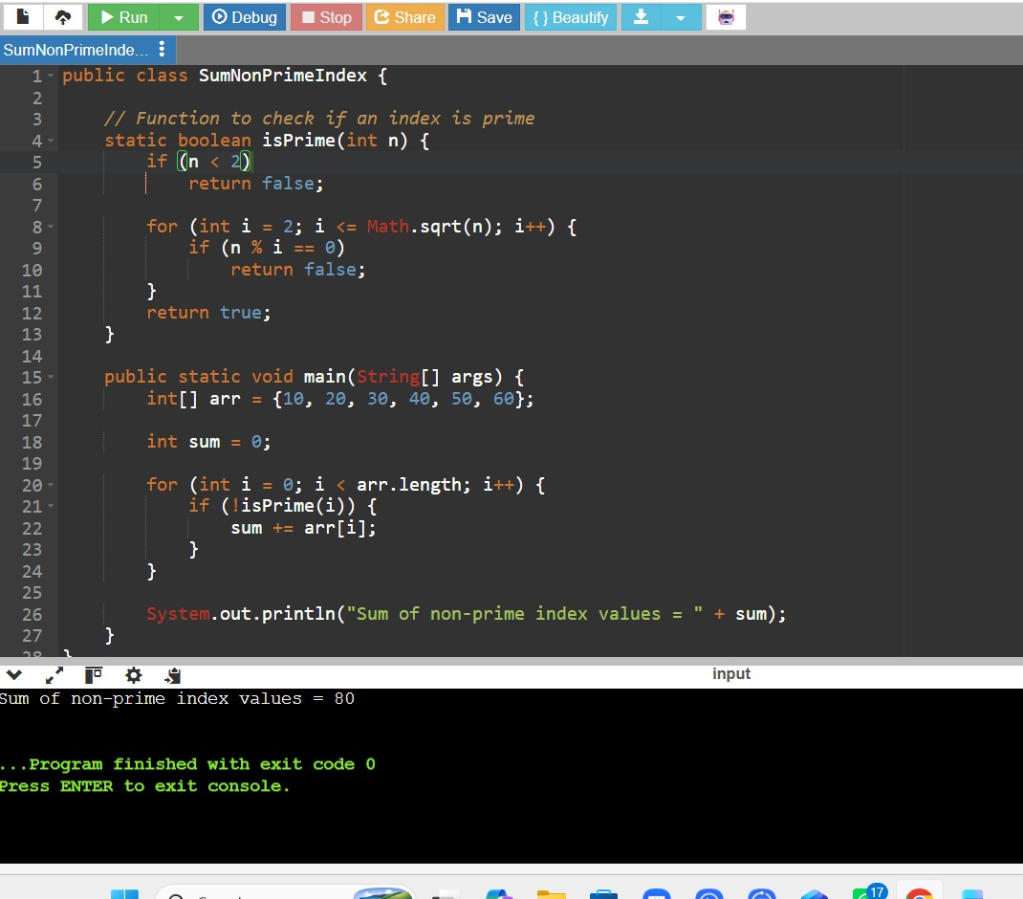
Task 10 : Return second word in Uppercase
